Presents
Jason Evert in the
CHASTITY PROJECT

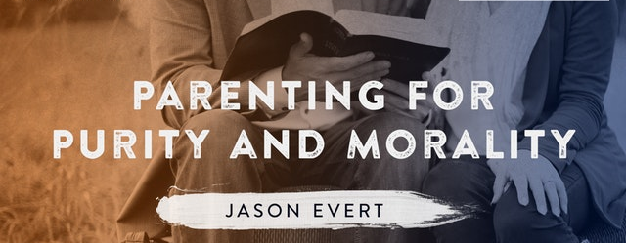
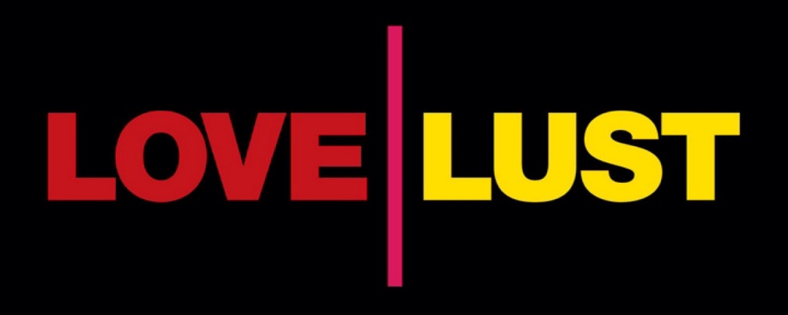

Sunday, December 16, 2018 at 3:30 pm
Parenting for Purity
(Parent audience-Parent Formation Credit)
Sunday, December 16, 2018
at 6:00 pm
Jason Evert - Love or Lust?
(Confirmation Youth Grades 7-12)
St. Thomas the Apostle Catholic Church
https://chastity.com
Limited Seating Arrive early
5150 N Valley View Rd, Tucson, Arizona 85718

